

Faculty of Business, Media and Management
Information systems department

AMANQOS ALQUAT

REPORT
OF EDUCATIONAL PRACTICE

Major 6B06105 – Information System
Group IT-2313

Practice supervisor: Alizhan Daruish

Grade: _____________

Almaty 2024

CONTENT

I.Introduction....................................................................................................3
II.Main part
1. make a simple autobiography website……………………………………...5
2.Coursera.org – Learning language of programming...................................... 6
3.Python language.……...……………………………………………..............7
4.Learning about loops...………………………………………........................8
4.Learning about classes.………………………………………........................9
III.Conclusion……….........................................................................................10

INTRODUCTION

- ### Report on the "Introduction to Teacher and Class" Event

- 1. Introduction
- Date and Time: June 3, 2024, 1:00 PM
- Location: Room 403
- Responsible Teacher: Alizhan Daruish
- Purpose: Creating a conducive learning atmosphere, establishing a connection between the teacher and the students.

- 2. Event Program
- - Teacher introduction.
- - Student introduction.
- - Discussion of behavior rules and expectations.
- - Introduction to the course plan and objectives.
- - Q&A session.
- - Conclusion and summary.

- 3. Event Description
- *Teacher Introduction*
- Teacher Alizhan Daruish introduced himself, shared his educational background, qualifications, and work experience.
- The teacher also shared personal information, including hobbies and interests, to foster a friendly atmosphere.
-he told how he spent almost 5 months in the USA and who he worked for.

- Student Introduction
- Students introduced themselves one by one, sharing interesting facts about themselves.

*Behavior Rules and Expectations
- Basic behavior rules for classes were discussed: respect for each other, active participation, timely completion of assignments.
- The teacher explained her expectations from the students: involvement, responsibility, and a desire for knowledge.

- Course Plans and Objectives
- The teacher presented the course curriculum, key topics, and objectives.
- The goals that students should achieve by the end of the course were explained.
- Various teaching methods to be used were discussed: lectures, seminars, group work, practical exercises.

- Q&A Session
- Students asked questions about the course, rules, and the teacher herself.
- Any doubts or suggestions from the students were discussed.

- Conclusion
- The event concluded with a summary.
- The teacher expressed hope for successful collaboration.
- Announcement of the next session and topic.

- 4. Results and Summary
- Students and the teacher got acquainted and established a connection.
- A positive and productive atmosphere was created.
- Students received all the necessary information about the course and its requirements.

- 5. Recommendations and Suggestions
- Conduct similar events at the beginning of each course to create a friendly atmosphere.
- Implement surveys to deepen understanding of the students.
- Regular Q&A sessions to maintain open communication between the teacher and students.

6. Conclusion:
- In conclusion, our first session of "Introduction to Teacher and Class" was successful. I believe an ideal atmosphere was created for introductions, and I want to highlight that our teacher, Alizhan Daruish, was a great conversationalist.
- He shared many interesting facts about himself and the course. And also talked about he spent time in USA. Our group was very pleased with how kind our teacher was.

This report summarizes the key points of the event and provides insights into its success and recommendations for future improvement.

Date: 4-5.06.2024 Time: 12:00 Room: 416

On the first day of our course, we met a teacher who tasked us with creating an autobiography website using only HTML. This was a fun challenge that required us to not only describe ourselves, but also present the information on the website in an attractive style. We not only created text content, but also added a background image to make the site more visually appealing. Additionally, we included a link that redirected us to another page, allowing us to further explore the topic of our autobiography.

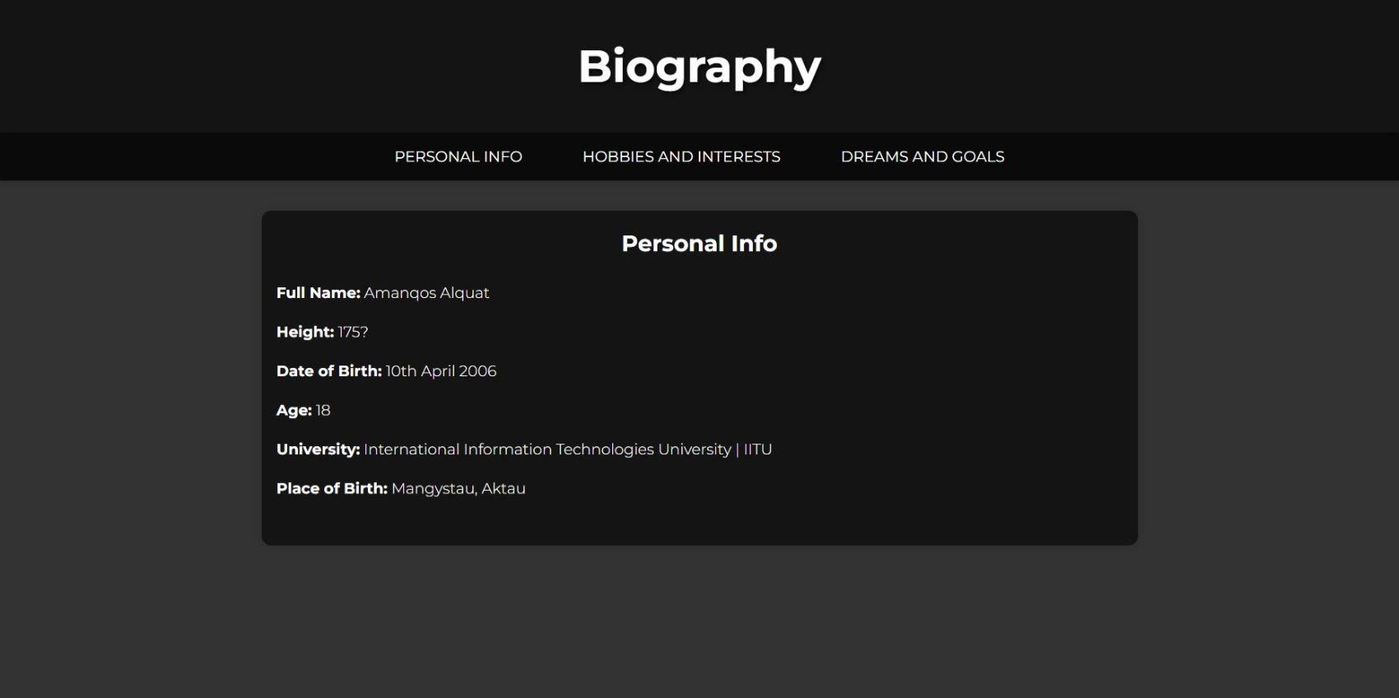
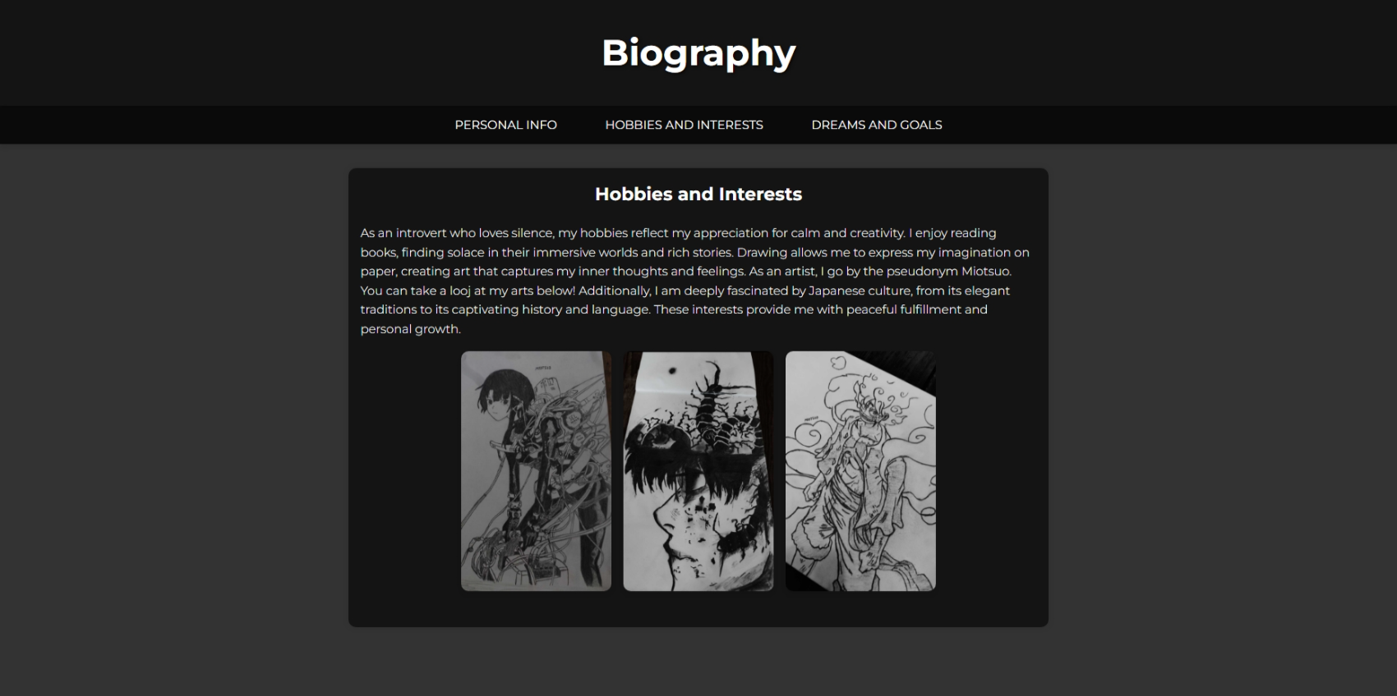
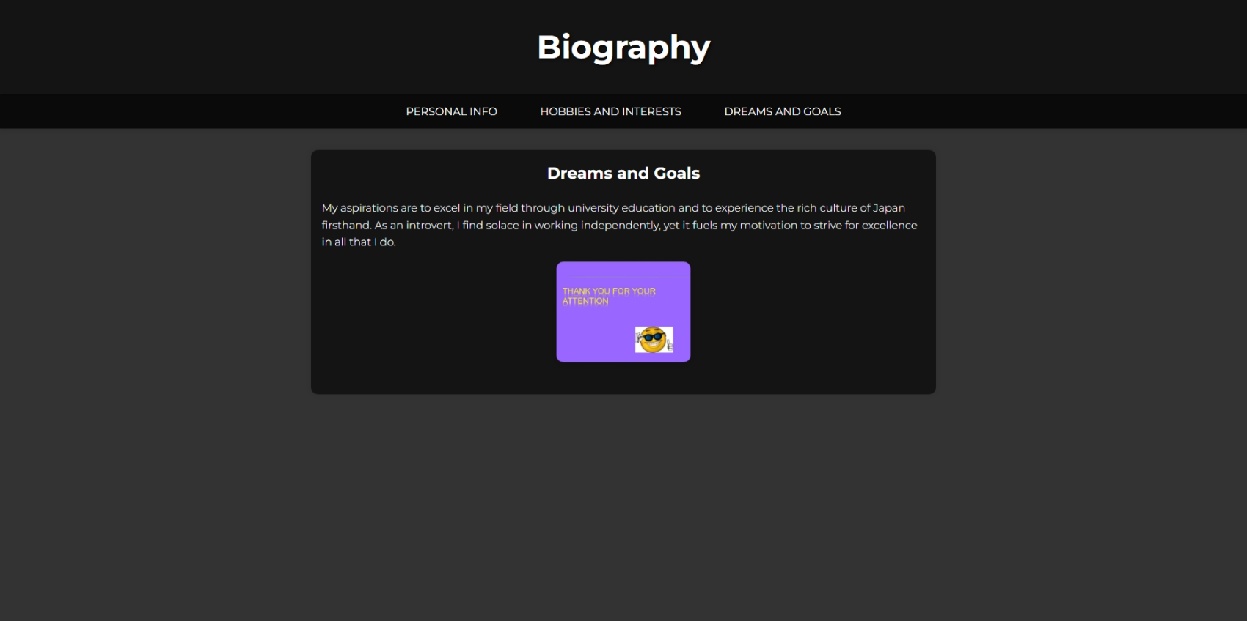

Date: 5-6.06.2024 Time: 13:00 Room: 416

Today, we attended a session in Room 401 where Alizhan Daruish briefed us about the course we are supposed to undertake. It was a Coursera course focusing on the Sml programming language.

General Information:
- Platform: Coursera
- Duration: 6 weeks
- Programming Language: Sml

Key Topics:
1. Introduction to Sml programming
2. Basic constructs of the Smllanguage
3. Working with variables and operators
4. Control flow operators in programming
5. Handling arrays and collections
6. Application of object-oriented programming

Course Features:
- Each week is dedicated to a specific programming topic in Python.
- Video lectures, practical assignments, and self-assessment tests are provided.
- Interactive learning is facilitated through online workshops.

Review:
The "Introduction to Programming" course on Coursera offers an excellent opportunity for aspiring programmers to grasp the fundamentals of Sml programming. The course materials are well-organized and presented in a manner that is understandable even for beginners. I highly recommend this course to anyone looking to embark on their journey in Sml programming. Sml was not a familiar programming language to me, but thanks to this platform, I was able to learn the basic concepts of Sml.

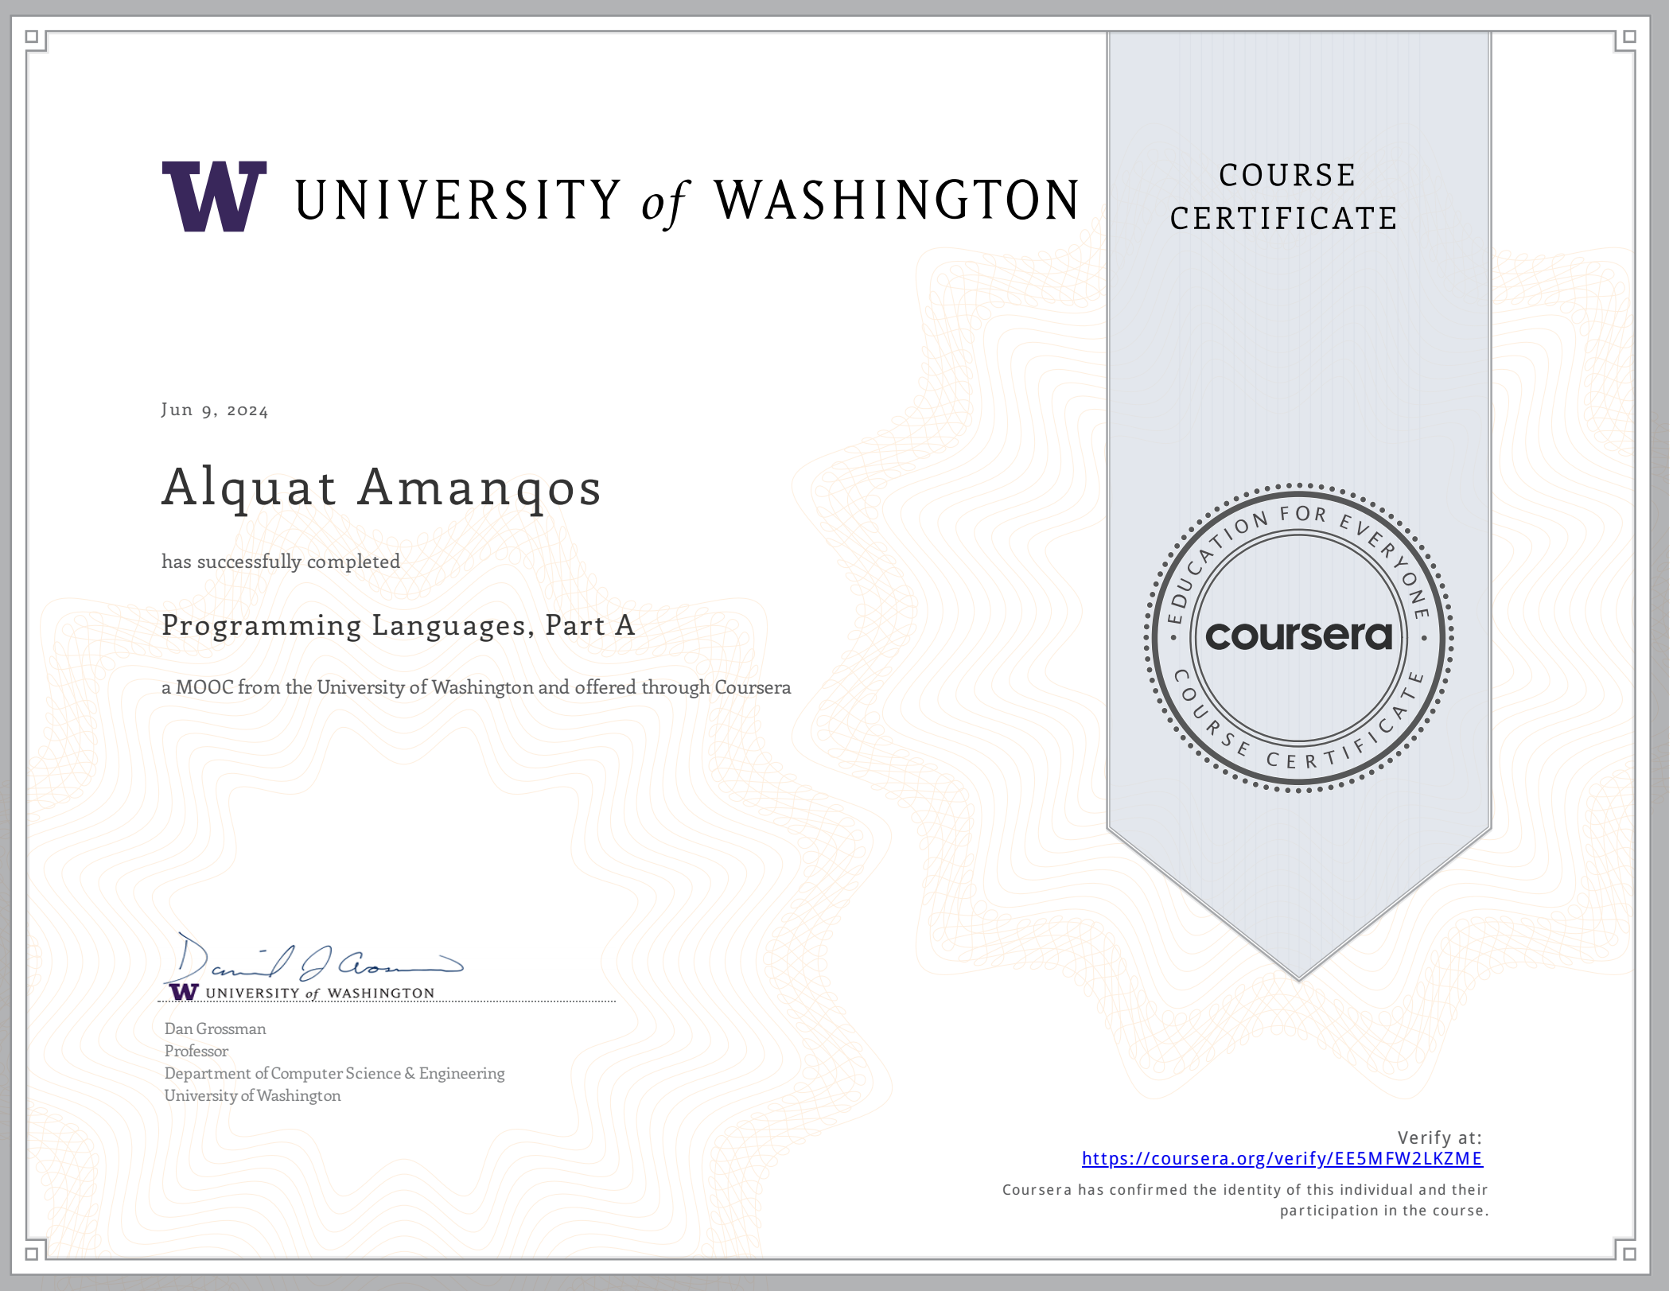

Date: 6-7.06.2024 Time: 12:30 Room: 401

Today in class we dived into the basics of Python and developed our own calculator. This project was an exciting experience that allowed us to not only learn the basic principles of Python programming but also put them into practice. We learned how to create functions for basic mathematical operations and organize user interaction through the console interface. This experience was not only useful, but also inspiring to further study programming.

Main Topics:
1. Basic constructs of Python
2. Working with math operators
3. Application of object-oriented programming in Python

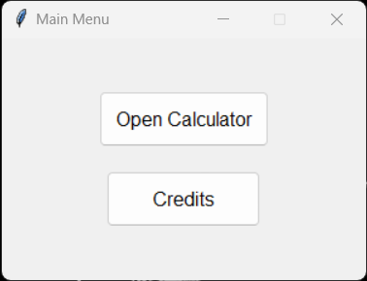
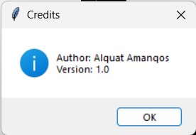
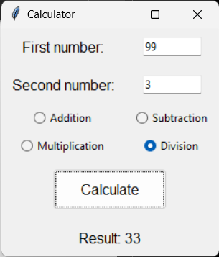

Review:
Today's session was beneficial for deepening our knowledge of the Python programming language. We learned how to create functions for basic mathematical operations and organize user interaction through the console interface. This experience was not only useful, but also inspiring to further study programming.

Date: 10-11.06.2024 Time: 12:00 Room: 416

Today we went through loops in the Python programming language. Loops are used to repeatedly execute a set of instructions until a certain condition is met.

We were also given homework to write some programs using loops. These assignments will help us better understand how to use loops in practice to solve various problems.

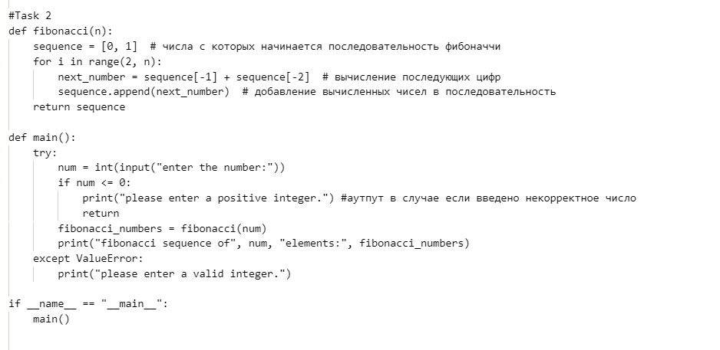
Review:
Loops are an integral part of programming, providing powerful capabilities for solving a wide range of problems.

Date: 12-13.06.2024 Time: 14:00 Room: 401

Today during our lesson we dived into classes in Python. Classes are a powerful object-oriented programming tool that allows you to structure data and functions into a single object. We started with basic concepts such as creating classes, defining attributes and methods, and using the __init__ constructor to initialize instances of a class.

As we explored, we created several example classes, each representing a different object or concept. We delved deeper into understanding encapsulation, inheritance, and polymorphism—key aspects of object-oriented programming that make code more modular, understandable, and easily extensible.
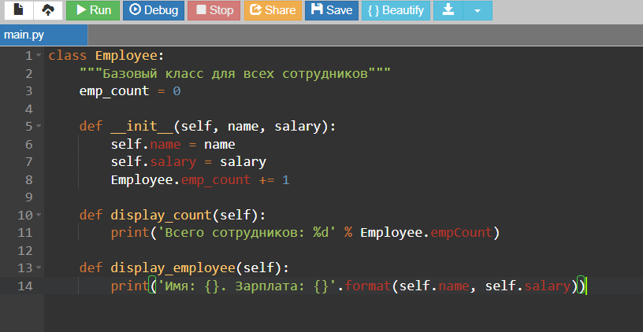

Review:

These concepts greatly facilitate the process of developing programs, improving their structure and code reuse.

Conclusion

Today marks the last day of our practical training.
The practice went smoothly, with each day filled with valuable information and practical assignments. We've mastered various aspects of programming and web design, allowing us to expand our knowledge and skills. Special thanks to our instructor, Alizhan Daruish, for his structured and informative sessions.
Personally, this practice has been extremely beneficial for me. I deepened my knowledge in Python, particularly in loops and classes. I learned to create a personal autobiography website using HTML, which enhanced my web design skills. Additionally, I completed a course on Coursera that introduced me to the SML programming language, providing a solid foundation in functional programming. Each lesson was a step towards professional growth and confidence in my abilities.

- Recommendations:

For continued successful learning and practice, I recommend:
- Regularly review the materials covered and complete practical assignments.
- Utilize various educational resources to deepen understanding.
- Participate in online forums and discussions to exchange experiences and knowledge.
This practice has been a significant milestone in acquiring new skills and knowledge, and I look forward to further opportunities for professional development.

